2nd Grade Math
Week #2: Number & Operations in Base Ten
Let’s review place value:
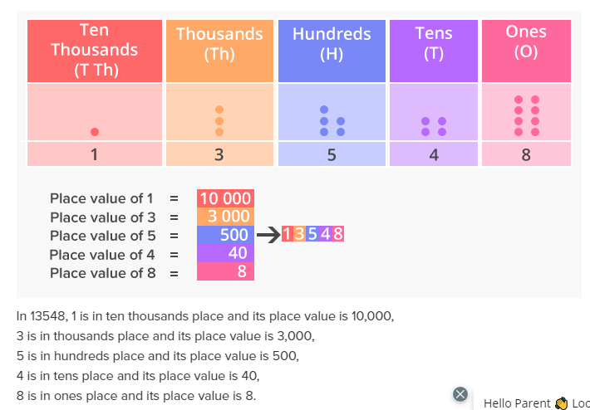
Knowing the place value helps us to write numbers in different ways:
Place Value: written as values ex. 5 hundreds 6 tens 8 ones
Number Form: written using only numbers ex. 568
Word Form: written using only words ex. five hundred sixty eight
Expanded Form: Written out into an equation ex. 500 + 60 + 8

Skip Counting:
Skip counting is when the same number is added each time to the previous number. We skip count to make counting things faster and easier. Please review the separate skip counting attachment.
Comparing Numbers:
We use < > = to compare two numbers.
< means less than
> means greater than
= means equal too
The easiest way to remember this is to know that an alligator always wants to eat the bigger number!

