Week #4: Worksheet

Read and answer each question:
- 9 inches of ribbons are needed for wrapping each present. How many presents can be wrapped with 6 yards of ribbons?

- Each parking spot is 8 feet wide. A parking lot has 24 parking spots side by side. What is the width (measured in yards) of the parking lot?

- There are two trees in a park. The taller tree is 6 feet 8 inches. The shorter tree is 6 inches shorter than half the height of the taller tree. What is the height of the shorter tree?

- The driveway in front of the brown house is 35 feet long and the driveway in front of the red house is 7 yards and 9 feet long. Which house has a longer driveway? By how much?

- Eric’s kite spool had 100 yards of string. At first, he let out 50 feet of string. Then, the kite rose for another 16 yards. How much string was left on the spool?

- Each roll of tape is 30.5 feet long. A box contains 454 rolls of tape. In total, there are about ___________ yards of tape.
- 500 b. 5,000 c. 15,000

- The average weight of a 5-year old boy is 45 lb. Jack’s weight is 4 lb. heavier than average. What is Jack’s weight?

- Emily’s dog weighed 14 Kg. The dog lost 800 g after it fell ill. What is the dog’s weight (in Kg) now?

- A baby boy weighed 8 lb. 6 oz. at birth. After two weeks, his weight was increased by 14 oz. What was the baby’s weight when he was two weeks old?

- The capacity of an elevator is 10 people. If the maximum weight for this elevator to carry is 980 Kg, what is the maximum average weight of each person?

- Each kitten in a litter weighs 7 oz. If there are 5 kittens in the litter, what is the total weight of the litter?

- The heaviest turtle in the world weighed about 910 Kg and the average weight of a baby elephant is 91 Kg. How many baby elephants did the heaviest turtle weigh the same as?

- A bus leaves for Portland at 4:30 p.m. It takes 1 hr. 25 min. to reach there. At what time will it reach at Portland?

- Sara sleeps for 7 hours 30 minutes in a day. For how many hours did she sleep in the month of January?

- The duration of a movie is 3 hr. 15 min. It starts at 6:30 p.m. When will it end?

- Rebecca has taken 20 days leave from her job at the office. Her vacation will start Monday, September 16. On which day and date will the vacation end?

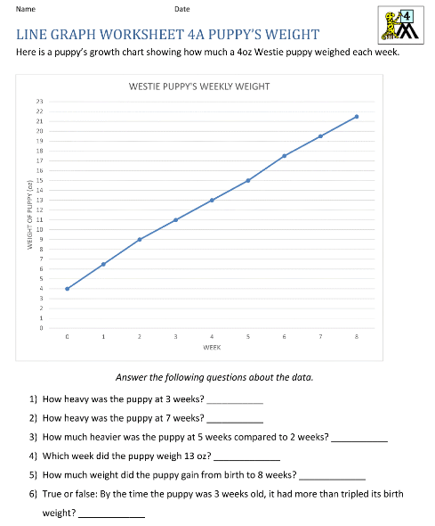
Please fill in the data on this bar graph using the following information:
You surveyed children in an elementary school to find out which of these five fruits are their favorite: apples, bananas, oranges, pears, grapes.
5 children liked apples, 10 children liked bananas, 8 children liked oranges, 2 children liked pears, and 2 children liked grapes.
_____________________________________________________________
________________ ________________ _______________ _______________ ________________

- Which fruit did the children like the most?
- Which fruit did the children like the least?
- How many more children likes oranges than apples?

